NetBrain Single Pane of Glass (SPoG) Integration_PRTG

NetBrain applicable versions: 7.1a1, 8.0

Contents

Instruction 2

What is NetBrain Single Pane of Glass (SPoG)? 2

How does NetBrain SPoG work? 2

PRTG API 2

Accessing Live Object Data and Live Status Data 2

Create NetBrain API Parser 4

Define NetBrain API Plugin 5

Test NetBrain API Server Instance Connectivity to PRTG Instance 5

Adding an External API Server 5

Test External API server result 5

Create NetBrain Qapp with NetBrain API Parser 6

General NetBrain Data View by NetBrain Qapp 6

Appendix 6

NetBrain API Plugin Code Standard 6

NetBrain API Parser Code Standard 6

# Instruction

## What is NetBrain Single Pane of Glass (SPoG)?

NetBrain integrates with different data sources within an enterprise to use NetBrain map and Qapp for data correlation, analysis, and troubleshooting.

## How does NetBrain SPoG work?

NetBrain has Python function defined in API Plugin to send HTTP/HTTPS request to 3rd party system to query 3rd party system data via REST API. End user needs to specify the 3rd party system REST API for certain corresponding data in NetBrain API Parser. NetBrain will then be able to implement the parser in a Qapp to further process the REST API retrieved data to generate NetBrain Data View on NetBrain maps.

This documentation uses display PRTG device’s sensor data as NetBrain Data View (DV) as an example to explain how PRTG SPoG is implemented in NetBrain system.

# PRTG API

## Accessing Live Object Data and Live Status Data

To define NetBrain API Parser, end user needs to first understand what data needs to be pulled from PRTG and the corresponding PRTG API to query such data.

Navigate to “PRTG API” page in PRTG.

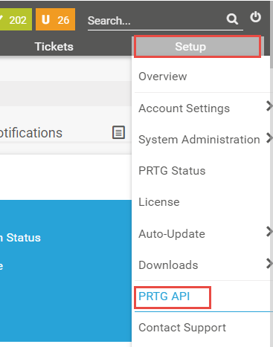

Brief introduction of using PRTG API

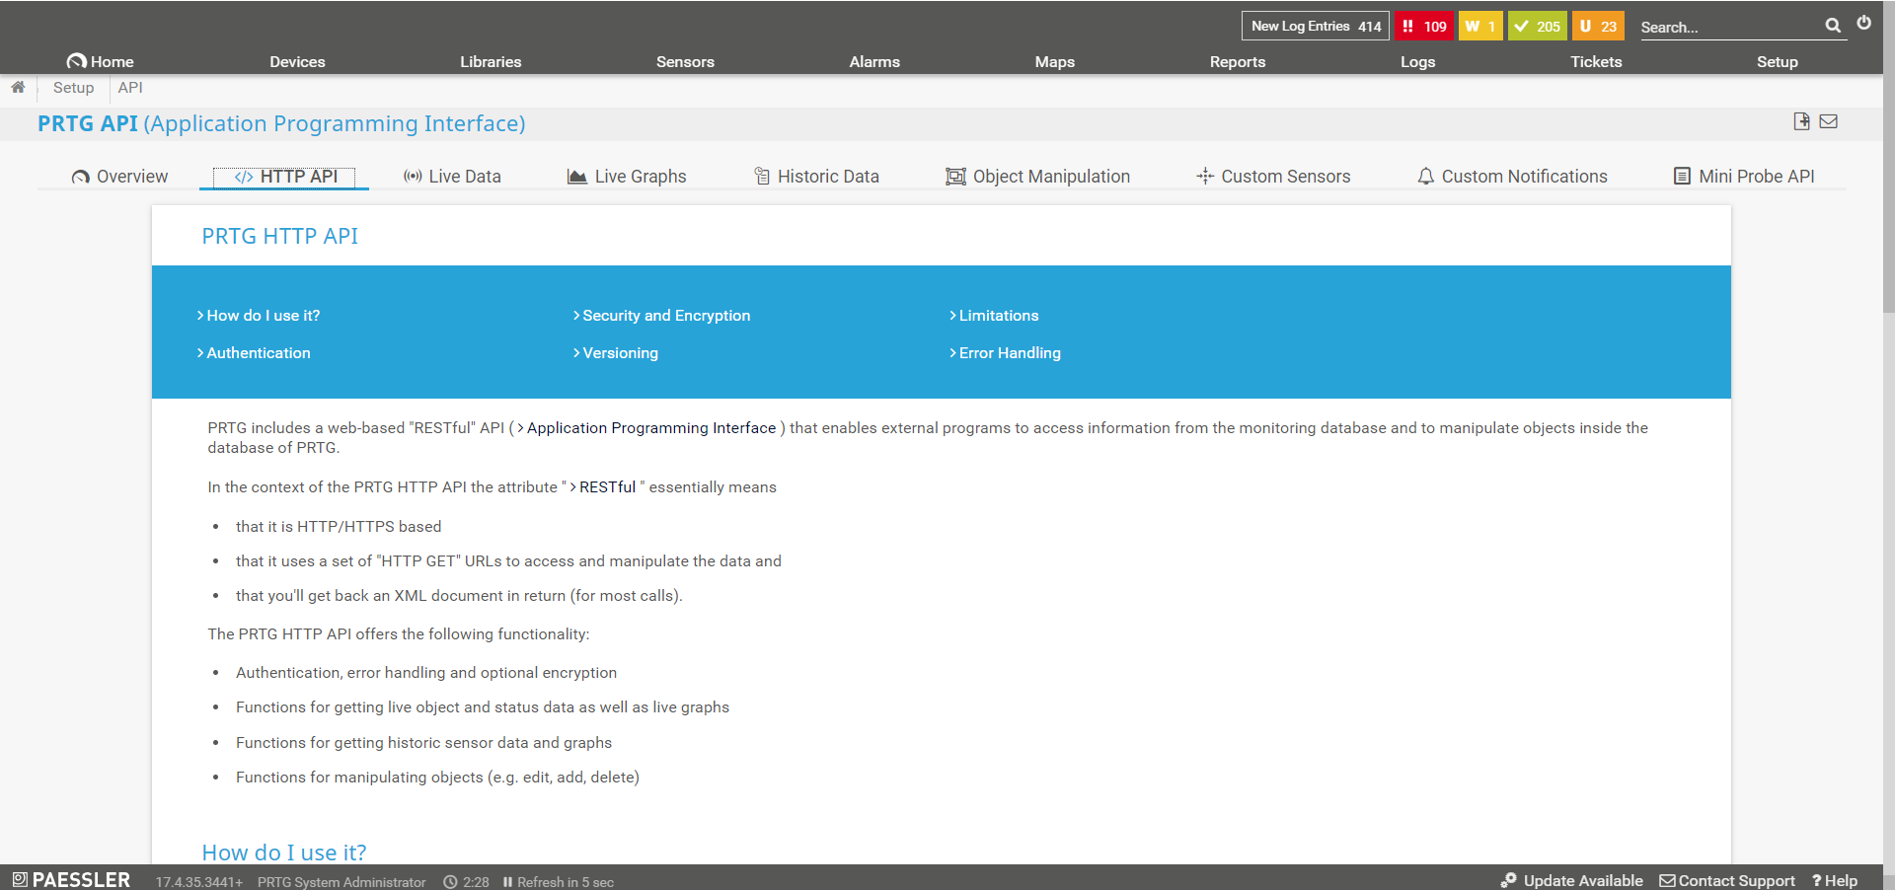

1. PRTG HTTP API

PRTG includes a web-based "RESTful" API ( Application Programming Interface ) that enables external programs to access information from the monitoring database and to manipulate objects inside the database of PRTG. The URLs consist of a path to the API function and some parameters. Here are two example calls:

Sample Call 1:

http://***yourserver***/api/table.json?content=sensortree

Sample Call 2:

http://***yourserver***/api/rename.json?id=objectid&value=newname

1. Check if data is in correct format, get path parameters and Query parameters.

Navigate to “PRTG HTTP API: XML Table Query Builder” to check if table query builder shows the JSON data returned from the API server.

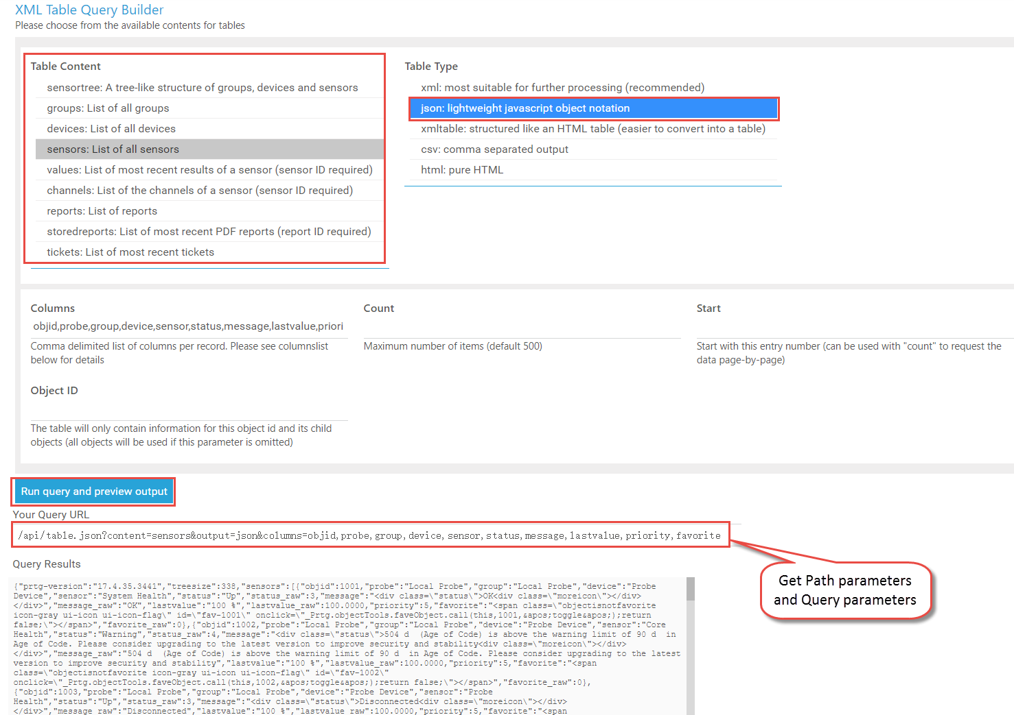

For more details on PRTG HTTP API, refer to [http://***YourServer***/api.htm?tabid=3](http://YourServer/api.htm?tabid=3)

# Create NetBrain API Parser

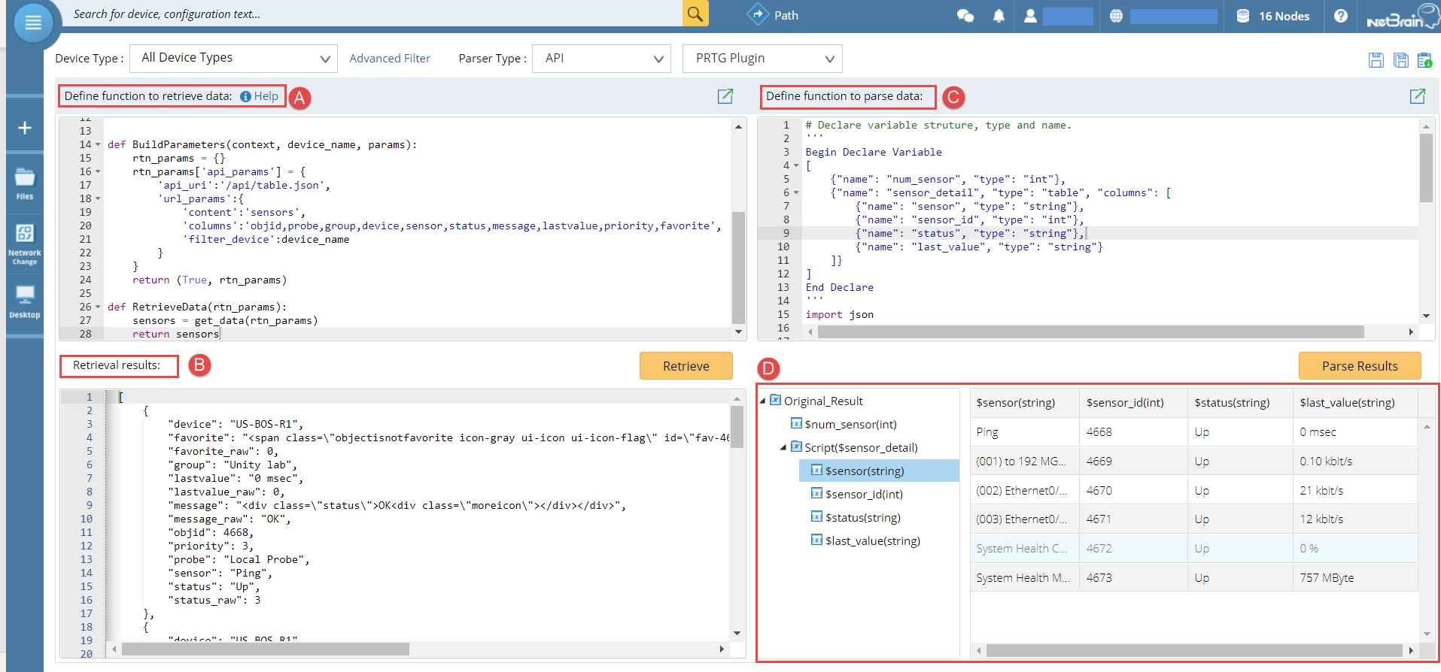

1. Define retrieve data function
   1. Customize Python functions:
      1. BuildParameters()

Define PRTG HTTP API parameters.

* api_url: PRTG API HTTP URI without host server domain name section
* url_params: PRTG API HTTP Query parameters
  + 1. RetrieveData()

Call API Plugin Python function to retrieve data via REST API

1. Review retrieved data
2. Define parse data function
3. Review parsed data

# Define NetBrain API Plugin

NetBrain API Plugin has a build-in instance for PRTG, which contains HTTP Get function (get_data()).

The HTTP request is using Basic Authentication to be authenticated by PRTG for each API call.

The username and password information are inherited from NetBrain **API Server Manager** instance.

No customization and modification are required in API Plugin.

## Test NetBrain API Server Instance Connectivity to PRTG Instance

### Adding an External API Server

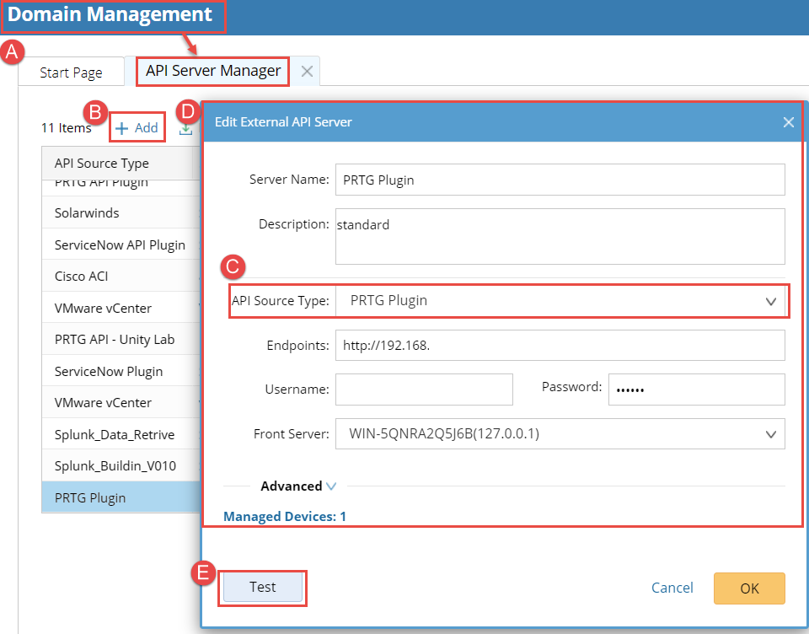

1. Open the Domain Management page, and navigate to **API Server Manager** tab.
2. Click **Add** button to add an External API Server
3. Select “**PRTG Plugin**” as **API Source Type**
4. Fill out all other fields in the pop-up dialog above
5. Click **Test** button to test connectivity from NetBrain Front Server to PRTG Server IP

### Test External API server result

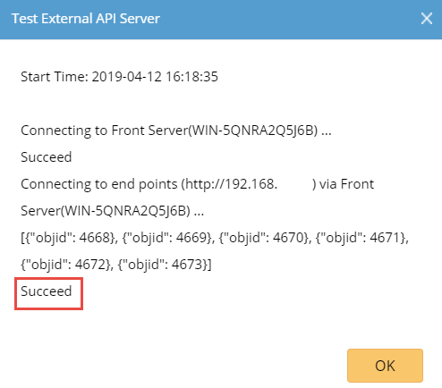

# Create NetBrain Qapp with NetBrain API Parser

# General NetBrain Data View by NetBrain Qapp

# Appendix

## NetBrain API Plugin Code Standard

1. To easily maintain and scale API Parser Library in the future, only extract parameters passed from Parser. DO NOT hard code any REST API HTTP parameters in API Plugin Python functions.
2. To prevent more HTTP request sending from NetBrain to 3rd party systems, use Basic Authentication for HTTP calls as long as 3rd party system supports Basic Auth.
3. To easily organize HTTP call parameters, return the following 4 values to get_data() function:
   1. endpoint: 3rd party system host address, which is defined in API Server Manager
   2. username: 3rd party system login username to be used by HTTP call, which is defined in API Server Manager
   3. password: 3rd party system login password to be used by HTTP call, which is defined in API Server Manager
   4. api_params: HTTP request parameters defined in API Parser
4. To simplify the output in API Server Manager Test result, trim the sample REST API call result as much as possible in _test() function.

## NetBrain API Parser Code Standard

1. Define HTTP request parameters in BuildParameters() function by following the Python dictionary structure below:

rtn_params['api_params'] = {

'api_uri':'/api/table.json',

'url_params':{

'content':'sensors',

'columns':'objid,probe,group,device,sensor,status,message,lastvalue,priority,favorite',

'filter_device':device_name

}

}

1. Trim the result by better defining the query parameters, instead of further process the returned result later in NetBrain parser.
2. Implement the main logics by calling API Plugin functions in RetrieveData() function